# Apply filters to SQL queries

## Project description

[Describe what you accomplish through SQL.]

## Retrieve after-hours failed login attempts

The task is to retrieve failed login attempts after work hours from the database.

Data retrieved from log_in_attempts. WHERE clause and AND operator are used to retrieve failed login data after 18:00.

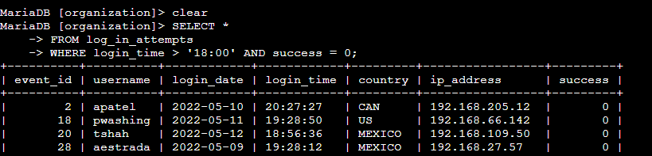

## Retrieve login attempts on specific dates

The task is to retrieve all login attempts from 2022-05-08 and 2022-05-09.

Data retrieved from log_in_attempts. WHERE clause and OR operator are used to retrieve login data from both dates.

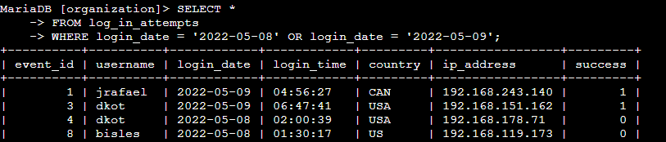

## Retrieve login attempts outside of Mexico

The task is to filter out Mexico from the table.

NOT is used to exclude country LIKE Mexico.

MEX% is used as the country field includes entries with 'MEX' and 'MEXICO'.

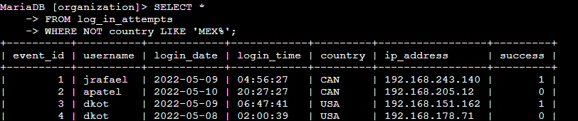

## Retrieve employees in Marketing

The task is to retrieve information about employees from the marketing department, who also work in the East Building office.

AND used to include department and office filters.

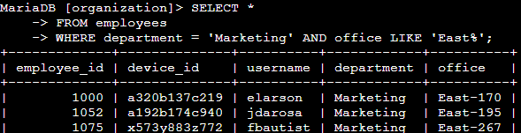

## Retrieve employees in Finance or Sales

OR used to include the Finance and Sales departments

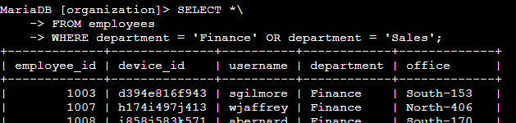

## Retrieve all employees not in IT

NOT used to filter out the Information Technology department.

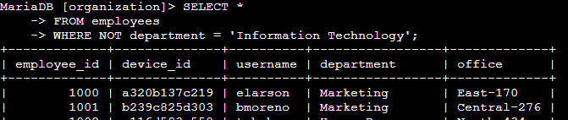

## Summary

I applied filters to SQL queries to get specific information on login attempts and employee machines. I used two different tables, log_in_attempts and employees. I used the AND, OR, and NOT operators to filter for the specific information needed for each task. I also used LIKE and the percentage sign (%) wildcard to filter for patterns.